**Abstract -** Chronic kidney disease (CKD) is an important public health issue. It describes abnormal kidney function and/or structure. Despite many other diseases, it is usually asymptomatic until the late stages. In small but significant percentage of people, CKD can progress to End-stage kidney disease, which requires a lot of personal commitment in order to survive. This includes strict diet and regular appointments for Renal Replacement Therapy (RTT**)** for the rest of the individual’s life.In the majority of cases, RTT starts with receiving dialysis treatments, until the living kidney is transplanted. Since the process of receiving a transplant requires a three year waiting in average, it is particularly important to maintain individual’s health until the kidney is transplanted.

The aim of this nine-month project is to develop an **everyday mobile application** that fits the needs of renal dialysis patients. Market research shows that there are very few mobile **applications** available for people on dialysis. Through an agile-based approach, an application was developed to (1) remind patients about their appointments, (2) Check their health by scanning their blood test results, (3) react immediately if health check failed, (4) prepare them for their treatments and assist them during these treatments, (4) allow them an easy access to their personal details, clinical staff contact details and frequently asked questions, (5) offer them calendar of events with an option to add their own events in the system, (6) **Show graphs of how their blood test results changed during time.**

The final solution is an Android mobile application sitting on the top of a SQL database back-end. The **service** utilises a variety of powerfull, unique **frameworks(libraries?),** including Android-volley[**REFERENCE**], MPAndroidChart[**REFERENCE**]. A typical user of the service **can interact with an application every day: before, during and after treatments.** This report gives an in-depth breakdown of the process under which the project was developed.

**Keywords***Dialysis, Haemodialysis, Chronic Kidney Disease, mobile applications, Android*

**1 Introduction**According to UK Renal Registry 18th annual report [1.1], there were 7411 new RTT patients in the UK in 2014. Apart from that, between 1980 and 2014, RTT incidence rate increased by more than 2 times and chances of RTT incident increased with population ageing. (Figure 1) Across the UK, as a whole, the renal replacement therapy incidence rate for 2014 was higher than for 2013 and 2012. In the worldwide, UK statistical data is not showing the highest incidence rate, according to data supplied by United States Renal Data System (USRDS) (Figure 1.1). It is self-evident that there are strong reasons to consider Chronic Renal Disease as an important public health issue, since despite of only small amount of CRD cases, where disease progresses to the Kidney failure which requires RTT, the amount of incidents is growing each year. [2]   
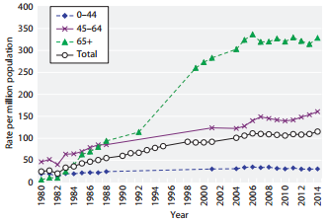  
***Figure 1****: RRT incidence rates between 1980 and 2014*

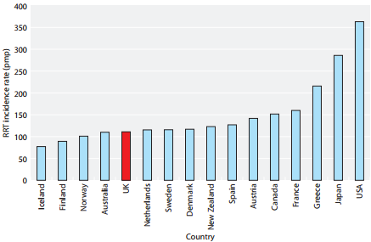

***Figure 1.1****: International comparison of RRT incidence rates in 2013(Data from USRDS)*[2.1]

In 2013, the total of 2613 RRT patients died for different reasons. Infection was the third most popular reason causing death in Dialysis patients. (Table 1)

Tayside Kidney Patients Association (T.K.P.A.) [2.2] is an association ran by volunteers. It aims to support Tayside Renal Patients by providing help and advice, when appropriate. Currently, T.K.P.A. **does not have any IT solutions apart** from the website. All the patients who joined T.K.P.A. are either running dialysis patients or those, who already received a kidney transplant. Unlike in many other associations, T.K.P.A. members are very close to each other, since they meet at least 3 times a week at the Renal Dialysis Unit in Ninewells Hospital. The most experienced patient in the association is receiving RRT for more than 30 years. T.K.P.A. is always here, when a CKD patients requires help or assistance.

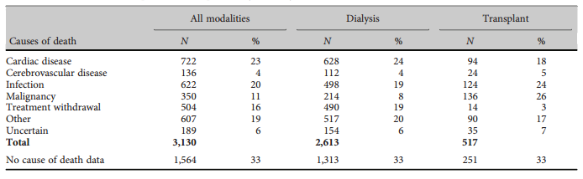

***Table******1****: Cause of death in prevalent RRT patients by modality, 2013*

This project is devoted to development and evaluation of Android application that would work as an everyday mobile application for RRT patients. The application is aimed to check patient’s health and help with patient’s preparation to the treatment, through the treatment and in their aftercare. The aim of the project is to produce a mobile application to support daily RRT patient’s needs.

This report describes the **incremental and iterative development procedure with elements of agile approach** the author took to develop a mobile **solution** for T.K.P.A.

**The remainder of this document presents background research providing context for the project (Section 2), the project proposal resulting from client discussions (Section 3), individual project handling techniques (Section 4), the design, implementation and testing process for each phase of development (Sections 5-7), a functionality and testing overview of the final product (Section 8), and a conclusive discussion including student reflection and notions for future work (Section 9).**

**2 Background**

**2.1 Kidneys**The kidneys are two beam-shaped organs, the size of the fist, located on either side of the body, just beneath the ribcage. The main role of the kidneys is to filter waste products from the blood before converting them into urine. Apart from that, the kidneys help to maintain blood pressure and the correct level of chemicals in the body which, in turn, helps heart and muscles to function properly. The kidneys also produce the active form of vitamin D that keeps bones healthy, and simulate production of red blood cells by producing erythropoietin. [1]  
**2.2 Chronic kidney disease**Chronic Kidney disease (CKD) is an important public health issue. It can be defined as the reduced ability of the kidney to carry out its tasks. In spite of it being common, with its popularity increasing with age, chronic kidney disease is an independent risk factor for other diseases, particularly cardiovascular disease. It often coexists with other cardiovascular conditions meaning that it needs to be managed alongside other diseases and risk factors such as diabetes and hypertension as well as the social needs that come with frailty and multiple conditions. In a small, but significant percentage of cases, chronic kidney disease progresses to end stage renal disease, which may require renal replacement therapy. This progression and the risks of other vascular events, such as stroke and heart failure can be reduced if chronic kidney disease is identified and managed, early diagnosis is therefore essential. There are five known stages of CKD. These stages are mainly based on measured or estimated GFR (Glomerular Filtration Rate) (Table 1.1) [2]

|  |  |  |
| --- | --- | --- |
| Stagea | GFR (ml/min/1.73 m 2 ) | Description |
| 1 | ≥ 90 | Normal or increased GFR, with other evidence of kidney damage |
| 2 | 60–89 | Slight decrease in GFR, with other evidence of kidney damage |
| 3A | 45–59 | Moderate decrease in GFR, with or without other evidence of kidney damage |
| 3B | 30–44 |
| 4 | 15–29 | Severe decrease in GFR, with or without other evidence of kidney damage |
| 5 | < 15 | Established renal failure |
| a Use the suffix (p) to denote the presence of proteinuria when staging CKD. | | |

***Table 1.1****: Stages of chronic kidney disease* [3]

**2.2.1 Causes of chronic kidney disease**A number of conditions can cause permanent damage to the kidneys and/or affect their function and lead to CKD. According to [4], diabetes, high blood pressure and ageing kidneys are the three most popular causes of CKD.

**2.3 End-stage kidney disease**End-stage kidney disease (also called end-stage renal disease (ESRD) or established renal failure (ERF) is the last stage of chronic kidney disease. It is caused by inability of kidneys to support patient’s body needs. Since the kidneys are performing one of the leading roles in the body, it is essential to maintain their functionality, which requires renal replacement therapy (RTT). RTT can take a number of forms; kidney transplantation, haemodialysis or peritoneal dialysis. Receiving a kidney transplant can be a very challenging process. According to [5]:

* Only around one in three people with kidney failure is suitable for a transplant.
* Not all kidney transplants are accepted by body.
* Ideally, kidneys will come from a close relative because of the likelihood of sharing the same blood group and tissue type.
* An individual who needs a kidney transplant, but don’t have a suitable living donor, will have to wait until suitable deceased donor kidney becomes available. On average, the waiting time is two to three years, but if the individual has a least common blood group or tissue type, the waiting time increases.
* From April 2014 to April 2015, around 3,000 kidney transplants were carried out in the UK, but there were still more than 5,000 people on the waiting list for a kidney by the end of this period.

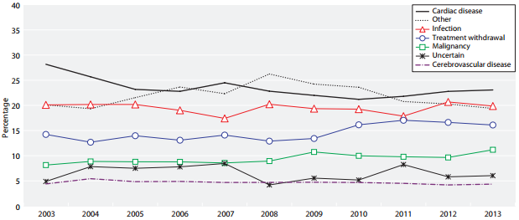

***Figure 2****: Cause of death in RRT patients by year*

Since the chances of obtaining a kidney transplant straight away after diagnosis are small, usually individual is offered a dialysis treatment, while waiting for a transplant.

**2.4 Haemodialysis**Dialysis is a procedure that is a substitute for many of the normal functions of the kidneys. Haemodialysis uses a dialysis machine with a special type of filter to remove excess waste products and water from the blood. There are multiple ways to connect a patient to the dialysis machine. One of them is known as “Cimino fistula”, which is a direct connection between an artery and vein in the arm. Haemodialysis can allow individuals to live productive and useful lives, even though their kidneys no longer work adequately.

**2.4.1 Causes of death during haemodialysis**Over the last years the quality of haemodialysis treatment within NHS Tayside improved with the help of modern medical technologies, but death rate within dialysis patients is still high. According UK Renal Registry [6], infection is one of the leading causes of death within dialysis patients (Figure 2). It is very easy to catch an infection, since fistula is the place, which is used as a link between the patient and dialysis machine. In order to decrease a death rate of Dialysis Patients, infections should be prevented at earliest stages.

**2.5 Important aspects of CKD patients’ life**Since their kidneys are not working properly, there is a number of life-changing guidelines which should be followed by people, diagnosed with CKD need to follow in order to improve their health. First of all, CKD patients follow special diet, which restricts their fluid intake and avoids potassium, phosphorus, salt, protein rich foods. Then, if the patient is undertaking RRT, attending haemodialysis appointments three times a week, 3 to 5 hours per treatment is essential. For new patients, following this strict schedule is of the most challenging adjustments needing to be made. [7] Apart from that, maintaining a hand hygiene is very important for people, who are undertaking their treatment through the fistula, since it is a very vulnerable place.

**2.6 Access to health check results for CKD patients/NHS medical staff**Currently, it is possible to access health check results from desktop computer using Patient View system [8], where registered patients can access their health check results and view them in a grid or table format. NHS medical staff are using eMed system to input results in the system.

**2.7 Market Research**The amount of mobile applications available on the market is very limited. According to National Kidney Foundation [9], there is a total of 4 applications available for the CKD patients. Most of them are pocket guides to nutrition assessment. Currently there are no applications available that offer RRT patient to view their blood test results explained on a mobile device. Apart from that, there are no applications that offer assistance during dialysis. On the other hand, there is a Patient View website available, it is **mobile friendly(REFERENCE)** and it allows patients to communicate with their doctor using messaging, but the blood test results shown there are very hard to understand due to abbreviations and medical terms being widely used. Moreover, instead of offering explanations for different blood tests using “**on click popup**”, in Patient View these explanations are only accessible from third-party websites. Summing up, there is no such a system that would offer RRT patients to access nutritional information, their personal details, essential clinical staff contacts, prepare them for their treatments, guide them through their treatments and review their blood test results in one mobile application.

**2.8 Client – T.K.P.A. (Tayside Kidney Patient Association)**Tayside Kidney Patient Association (hereafter referred as “the client” is an association ran by volunteers. Following a meeting with T.K.P.A., the student consulted with the head of association, Audrey McHugh and **came to an agreement over the Honours Project proposal**. The client’s aim is to help new and ongoing patients with CKD. The client is currently missing a mobile application that could offer both renal specific features and a part of existing functionality of the Patient View system.

**3 Specifications   
3.1 Project Selection**Before having initial meeting with a client, the project required ethical approval. Since RRT patients are considered disabled under Equality Act 2010, primarily the student was advised to apply for NHS ethical approval [10] and Caldicott Guardian ethical approval [11]. Initially there were many reasons for selecting advanced ethics. First of all, such an approval would allow to visit Renal Unit and speak to RRT patients on NHS grounds. Then, easy recruiting of patients for design evaluation would be possible. Finally, Caldicott Guardian ethical approval allows to request a real medical data that could improve the precision of application when performing a health check. Unfortunately, Caldicott Guardian ethical approval was not granted, because it required to state, which specific blood test results and other medical information are required for the project. During initial state of the project, interviews with NHS staff were not held yet, and in order to minimise risks it was decided to abandon the idea of getting Caldicott Guardian ethical approval for study. Apart from that, due to the fact that getting NHS ethics is a very long process, there existed a possibility that it will not be possible to get ethics approved in time, allocated for the project. Instead of getting NHS ethics, the student decided to find a patient association that is not directly connected to NHS and use a standard **Dundee University School of Computing Ethical Committee approval.** This solution significantly decreased time spent on ethics approval. On the other hand, it restricted the student from speaking to patients on NHS grounds, which made a patient recruitment more challenging. While ethics were awaiting approval, the student created a first version of project proposal and made an attempt to contact a client for the first time. Unfortunately, the only way to contact the client was by using a form on their website, which was not working properly. Later, when calling Renal Dialysis Unit, charge nurse transferred student to the client. Once the ethical approval was granted, an initial meeting with a client was set up on 18/11/2015. During this meeting first version of project proposal document was reviewed and updated. The student was not given any specific technical implementation guidelines, the client asked to consider an average age of the patients (55 years old) when developing an application. The client also added, that majority of the patients have either minimal **or no** computer skills. Apart from that, it was mentioned that despite the fact that large part of the existing RRT patients **has** basic skills of understanding their blood test results, there is a significant amount of patients, who do not understand them and require help of understanding them, which usually require waiting until they meet their consultant and discuss them. Client added, that it would be much better, if there was a way to offer patients an easy explanation of their results in order to be able to seek help straight away if they **notice big changes in their results**. It was agreed, that design workshop will take place due to clients interest in considering patients’ age in application development. The client was asked to find a group of volunteering patients from association who would be interested to participate in a **product design evaluation and testing.** The client expressed interest in the **idea** and future collaboration. The following key outcomes of the meeting were delivered: updated project proposal, information on CKD related websites, and related medical contacts of people, who contribute into association and can be helfpful with medical aspects of the research, CRK and, more importantly, RRD medical leaflets.

**3.2 Background**The client had around 60 patients and 5 NHS nurses and 10 other members involved in the organisation. It is important to note that due to nature of the disease (see Figure 1), most of the members are considered as an older age group patients. Apart from that, the client already mentioned, that large part of organisation members has minimal or no computer skills. The client had a basic website, but it was planned to upgrade it in the future, so the website could support user authentication. It was also planned to extend the functionality of the current website so it could provide user with a range of new options, such as contacting their clinical staff, looking up the blood test results, communicating with each other, having a treatment timetable accessible from the website. When these changes will have taken **place**, the client suggested, that a mobile application that provides the user with tools for everyday uses (at home or during their treatment) and part of the website’s functionality will be required. The client proposed the concept to create a **mobile** application, after discussing potential functionality required with RRT patients within organisation and some members of the clinical staff.

**3.3 Designer – Anna Morozova (3rd year Digital Interaction student at University Of Dundee)**Anna Morozova (hereafter referred as “the designer” is 3rd year Digital Interaction student, currently studying at University of Dundee. Designer was recruited by the student to create a user interface for the application, project poster and provide design skethes. Both student and designer would benefit from this decision. First of all, the student would benefit from the proper application design, since Digital Interaction students are taught to create user interfaces for different digital solutions according to international standards. Designer would benefit from being able to include her work to personal portfolio with reference to particular Honours Project.

**3.4 Initial Proposal**Shortly after the initial meeting, the head of T.K.P.A. had to resign from the project for 5 months due to personal circumstances. According to outcomes of the initial meeting with a client, the student generated a proposal document (**Appendix G**) which contained a number of implementation guidelines to outline the basic functionality required from the application. During proposal document design it was decided to minimalize client’s involvement in the project until the client returns from leave. The guidelines stated below were constructed as a result of this action.

**Assistance to be provided by the client**

* Patients on RRT for design evaluation

**Primary functionalities expected from the system:**

* **to have very ”user friendly” design**
* to offer user registration and authentication
* to assist user during the treatment by showing a treatment timer and progress bar
* to prepare user for the treatment by showing information on hand-hygiene importance when starting RRT and giving advice on fluid intake and nutrition during the RRT.
* to retrieve essential contacts from the database and display them under separate menu item
* to retrieve events assigned for user from the database and show them in a calendar
* to retrieve patient’s details from the database and display them under separate menu item
* to retrieve frequently asked questions and answers and show them under separate menu item.

**Secondary functionalities possible for the system:**

* to add personal events
* to change personal events
* to notify user for upcoming events
* a possibility to call telephone numbers in the application.
* a health check that checks blood test results (according to normal values for these blood tests) and indicate if the result failed
* to view graphs of blood test result changes through the time
* a possibility to call NHS 24 if health check failed

**3.5 Further Discussion**Due to client resigning from the project for 5 months, student had to take a risk of waiting until the client comes back and move evaluation of the application to the very end. Such risks were evaluated and risk assesment document was created (**Appendix E**). allocated for the project.

Due to medical nature of data that would be used by a **system** the student decided to recruit medical staff for assistance with medical part of the system. 2 NHS nurses and 1 NHS registrar were recruited as a result of this decision. After meetings were held with medical staff the following information was gathered:

* blood tests used for RRT patients
* normal values for these tests (taking into account that RRT patient’s blood is tested)
* routine checks made by medical staff when they are identifying if there are concerns about patient’s health and how frequent these checks are
* nutrition restrictions for RRT patients
* fluid intake restrictions for RRT patients
* information about dialysis treatments, their difference and special aspects of each, the routine of treatment, time of the treatment by default, how the patient is prepared for the treatment, what happens during the treatment and what steps are taken before patient is allowed to go home
* Information on medical staff that can be considered as core and can be included into essential contacts.
* Information on preferred method of contact when medical staff is contacted by patients
* Information on type of patient’s personal details, that have the most importance for RRD patients
* hand hygiene aspects for RRT patients
* RRD and CKD specific websites with useful information that can be used for the project [12],[13],[14],[15]

**4 Project Management**From the proposal discussion held between client and student, an outline of project development was constructed. Initially, it was planned for the main development procedure to be based on an agile approach, however due to client’s resignation from the project for uncertain time, it was not possible to construct a typical, business-valued product backlog or carry out sprints in the traditional manner. The student decided to become a product owner for uncertain time, either until the project ends or until the client will resume from the leave. There were multiple reasons this action. The main reason was that due to client’s unavailability to participate in the project for uncertain time or provide end users for evaluation, it was not possible to follow strict agile model. The reason for this was the fact that agile model is bounded to its Agile Manifesto [16] and 12 principles [17] and situation with the client made a clash with the following principles of Agile Manifesto:

* “Business people and developers must work   
  together daily throughout the project.”
* “Agile processes promote sustainable development. The sponsors, developers, and users should be able to maintain a constant pace indefinitely.”

At the same time, by becoming a product owner the student could have a full control on the project, perform sprint review and retrospective, create user stories, prepare acceptance tests for these user stories. This meant that the student had a full creative control over the development cycle and the planning of project.

The number of tasks were created for the project**. For time management purposes, these tasks were divided into months until the project deadline.** Then, five clear sprints emerged from the planning process:

* Pre-development: requesting a **PHP namespace** on Dundee University School of Computing ZENO server and SQL database on Dundee University School of Computing SILVA server, SQL Database schema generation, filling database with mock data, submitting ethics, meeting with NHS staff and a client
* Back-end at server side: Developing PHP scripts for data retrieval.
* Back-end at client side: developing server-client based Android Application
* Front end: application user interface
* **Design evaluation and testing**

These cycles were named Phase 0, Phase 1, Phase2, Phase 3, Phase 4 respectively. Expected time allocation for each task in the phase was estimated by the student and by summing up all these time allocations, the total time needed for the phase was estimated. As the result of this action, the project timetable was created (see Table 4).

|  |  |  |  |
| --- | --- | --- | --- |
| **Phase** | **Start** | **End** | **Length** |
| 0 | Nov 2015 | Dec 2015 | 4 weeks |
| 1 | Dec 2015 | Mar 2016 | 14 weeks |
| 2 | Jan 2016 | Apr 2016 | 13 weeks |
| 3 | Mar 2016 | Apr 2016 | 8 weeks |
| 4 | Apr 2016 | Apr 2016 | 1 week |
|  |  |  |  |

***Table 4****: Projected development cycles in timetable*

The project cycle planned for **16 weeks of** development, commencing the week on 6th December 2015 and ending on 15th of April 2016. The final 2 weeks were to allow for code refactoring and academic deliverables.

**Risk Assesment**According to [20],

**Personas**According to [21], the purpose of personas is to create reliable and realistic representations of your key audience segments for reference. These representations should be based on qualitative and some quantitative [user research](http://www.usability.gov/what-and-why/user-research.html) and [web analytics](http://www.usability.gov/what-and-why/web-analytics.html). Creating personas would provide a significant benefit for the project. Personas help to focus decisions surrounding site components by adding a layer of real-world consideration to the conversation. They also offer a quick and inexpensive way to test and prioritize those features throughout the development process. During the Phase 3 of the project, personas, along with use cases, user stories and requirements would allow the system to benefit from better user interface design. Document containing personas **[APPENDIX NUMBER]** was created, after the potential benefits personal could offer to the project were taken into consideration.

**Use cases**According to [22], a use cases is a written description of how users will perform tasks on your website.  It outlines, from a user’s point of view, a system’s behaviour as it responds to a request. Each use case is represented as a sequence of simple steps, beginning with a user's goal and ending when that goal is fulfilled. Use cases offer number of benefits, for example they help in explanation of how the system should behave and help brainstorming. Apart from that by using use cases it is easier to predict what could go wrong. They also provide a list of goals and this list can be used to help in establishing the cost and complexity of the system. Creating use cases document [**APPENDIX NUMBER**] helped student to negotiate which functions become [requirements](http://www.usability.gov/how-to-and-tools/methods/requirements.html) and are built.

**Example of USE CASE**

**Requirements specification**Software requirements are description of features and functionalities of the target system. Requirements convey the expectations of users from the software product. Requirements specification document (**Appendix NUMBER**) was created for the project according to IEEE Recommended Practice for Software Requirements Specifications (IEEE Std 100-1992)[18]. The document included a list of functional and non-functional requirements that were established from the problem specification based on the earlier discussion with the client and NHS Renal Dialysis Ward staff. The rationale for each requirement was created. As stated in [19], requirement rationale is an explanation of the reasoning behind the decision, statement of requirement, design approach etc. The requirements document was created when the client resigned from the project and the student became the owner of the project. During that period, the student was thinking of methodology change and this is the one of the reasons why requirements specification document was created instead of creating the list of user stories**, as usually done when using** agile methodology. The other reason for this action was the fact, that user stories provide a good cover over functional parts of the system, while it is still challenging to produce a good list of user stories that cover non-functional parts of the system, such as security and access times. After considering these **two facts**, the list of user stories was created from the list of generated project requirements.

REQUIREMENTS EXAMPLE

**User stories**User stories are one of the primary development artefacts in agile software development. A user story is a very high-level definition of a requirement, containing just enough information so that the developers can produce a reasonable estimate of the effort to implement it, as stated in [23]. The student decided to use "as an X, I want Y so that Z..." format, because the client initially had basic skills of using a computer and when the client resumed from the leave, such an easy to understand high-level format would make it possible for the client to review the list of user-stories. Due to client’s unavailability the student made a decision to involve some of the NHS clinical staff who supervised RRT patients on daily basis to sort existing user stories, accept or decline them and add new user stories. Also, staff was asked to write **acceptance tests for all the stories**, based on best of their knowledge about RRT patients’ routine. The effort needed to finish each of the user stories was calculated. As a result of this teamwork, the document, containing user stories with acceptance tests and completion estimates for each of them was created [**APPENDIX NUMBER**].

USER STORY EXAMPLE

**Project backlog**According to [24], A product backlog is a prioritized list of work for the software developer that is derived from the roadmap and its requirements. The most important items are shown at the top of the product backlog so the software developer knows what to deliver first. The software developer doesn't work through the backlog at the product owner' space and the product owner isn't pushing work to the development team. Instead, the development team pulls work from the product backlog as there is capacity for it by iteration. The student considered multiple tools available for managing a student backlog. There were 5 tools to choose from: Microsoft Office Excel spreadsheet, Trello, Pivotal Tracker and Yodiz. After considering pros and cons of each tool, the student decided to use Pivotal Tracker, mainly because it offered free subscription for students, it allowed various analytical tools, for example easy generation of productivity charts. It also had extended amount of included features available, if compared to its competitors and offered suitable user interface. The project backlog hosted on Pivotal Tracker [**LINK AND APPENDIX**] was created as the **result of these considerations.** On weekly basis, the backlog was reviewed and updated. An initial estimate (in **points**) for how long the task may take to complete was allocated and progress marked per week as appropriate (**sprint backlog**). Pivatal tracker included 4 columns for different progress of tasks: backlog, current and done. Each task was automatically moved into definite column during its lifecycle. In order to control it, the task had the following buttons: Start, Finish, Deliver, Accept/Reject, each moved the task to **representing column**.

**Definition of Done**According to **[X1**], Definition of Done is a simple list of activities (writing code, coding comments, unit testing, integration testing, release notes, design documents, etc.) that add verifiable/demonstrable value to the product. Focusing on value-added steps allows the developer to focus on what must be completed in order to build software while eliminating wasteful activities that only complicate software development efforts. The Definition of Done was also produced by the student and added to the Product Backlog [**LINK AND APPENDIX**]. **Student decided that in order to consider the feature as “done” must have contained the refactored code, compiled without errors, included coding comments where appropriate and had a user interface.**

**Class Diagram**Class Diagram provides an overview of the target system by describing the objects and classes inside the system and the relationships between them. Class diagram offer a number of potential benefits for the project. Mainly, because it provides a wide variety of usages; from modelling the domain-specific data structure to detailed design of the target system. Class diagram for the project **was generated in Android Studio** and can be viewed in [**APPENDIX NUMBER**]

**Database schema AND ER DIAGRAM**A database schema is the skeleton structure that represents the logical view of the entire database. It defines how the data is organized and how the relations among them are associated. It formulates all the constraints that are to be applied on the data [26].

ER DIAGRAM DEFINITON

In order to generate a proper ER diagram, information gathered from interviewing NHS staff was carefully studied. This information lead to the proper structure of “medical_history”, “profile” and “contacts” tables. In order to create the rest of the tables, **updated project proposal document**, user stories, use cases and class diagram were carefully studied. This lead into creation of database schema for the project (**Image X) and the following ER Diagram (IMAGE Y). Full ER DIAGRAM of the database can be viewed in [APPENDIX NUMBER]**

Preview of DB SCHEMA

**Weekly meetings with project supervisor**Formal supervisory meetings were used as an opportunity for the student to discuss the progress, describe findings and alert project supervisor of any problems. At the beginning of the project, it was agreed that these meetings will be held every Thursday on weekly basis during first and second semesters. For special occasions, such as going on an arranged holiday, unavailability during other module deadlines or sickness meeting were cancelled or moved to a different date. After every meeting, the meeting minutes were recorded into the project logbook.

**Meeting minutes**Meeting minutes are the written or recorded documentation that contain information about what was discussed and what happened during a meeting. The meeting minutes are generally taken or recorded during the meeting so that participants have a record of what happened during this meeting. The meeting minutes for the project were recorded into the project logbook during or after every meeting with a project supervisor and then **rewritten into the Google Docs document created specially for this purpose [REFERENCE]**.

EXAMPLE OF MEETING MINUTES

**Sprint review and retrospective**In Scrum, Sprint review is the process of demonstrating the features produced during the sprint to the product owner and anyone else who is interested. After the final sprint, the product owner is demonstrated with the final product. Sprint retrospective, according to [**X2**], is an inspect-and-adapt activity performed at the end of every sprint that involves continuous improvement opportunity for a Scrum team to review its process (approaches to performing Scrum) and to identify opportunities to improve it. Sprint review was performed by the student after completion of each of the project phases. Since the student became a product owner, it was decided to give that presentations to the project supervisor. After the review gathered from the supervisor and according to personal acknowledgement of problems and other challenges that occurred during the sprint, **Sprint Retrospective was performed on weekly basis.** These activities leaded to constant improvement of the software development quality. Every time, when Sprint review and sprint retrospective were performed, the outcomes were recorded into the logbook.

**Ethical approval (ALREADY IN PROJECT SELECTION)**

**Version control system**According to [**X2**], version control system (VCS) is a system that records changes to a file or set of files over time so that it is possible to recall specific versions later. There was a number of VCS to choose from. The student decided to choose Git due to having extensive amount of previous experience with this CVS. **Followed by the fact** that the student had multiple computers in use, the decision was made to store created Git Repository on a web-based Git repository hosting service called GitHub. GitHub offered a number of additional tools, such as good user-friendly interface and tools for analytics in graphs: contributions to master, code frequency, commits per day/week/month. One of the most useful tools available in GitHub is “Issues” section. When spotting a code or design issue, reporting it is the best practice software developer can take in order to make sure that it is solved afterwards. During software development phases of the project, “Issues” was constantly used by the student.[**IMAGE X ISSUES**] Every tool described in this section made it possible to make an additional improvement on planning and time managements during sprint retrospective. It is possible to view a repository in [**X3 LINK TO GITHUB**]

Screenshot of Issues section

Screenshot of Github Repository

**Logbook**As specified by requirements for project final portfolio, a diary of effort spent each week on tasks, initial ideas for program designs, design decisions and design sketches, trade-offs, notes, simple evidence of ideas development or, in other words, all the rough work done for the project was included in the project logbook (**Appendix NUMBER**). Undoubtedly, the project benefited from having a logbook, since it was used all the time for sketching ideas, making notes, especially during the software development part. Logbook was also used when arranging meeting with the client and NHS staff, doing design evaluation and application testing. When the student was writing a project report, logbook was used as well for planning purposes.

**Twitter Account**In order to get public interested in the project, twitter account @dialysis_app [**REFERENCE**] was created. It was decided to use social media to post progress made on the project. Time after time, the progess was tweeted. The software development part of the project would not directly benefit from having a twitter account, but undoubtedly, it could be used for increasing public awareness of CKD. Apart from that, the chance existed, that some of the people on RRD will notice this twitter account and provide “handful of additional advice” on features to include in the application.

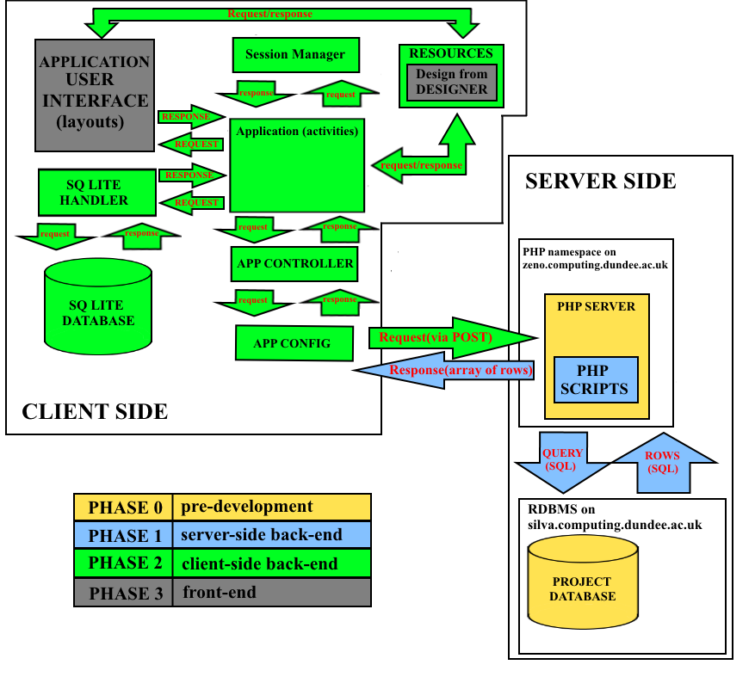

**Figure X:** *Expected system architecture including project phase breakdown.*

**4.1 Phases**Each of the development phases contained a clear breakdown of tasks and formed a product backlog. Part of the tasks was dependent on its predecessor, while some parts were not due to some of the features being separated and not dependent on each other. The features that were dependent on their predecessor were prioritising the backlog. A physical agile board was set up by the student to track the progress of each task under the headings “to start”, “in progress”, “testing” and “completed”.

PHOTO OF THE BOARD

**Phase 0:** *pre-development*

1. Ethics submission
2. Meeting with NHS staff and client
3. Request a **PHP namespace** on Dundee University School of Computing ZENO server and SQL database on Dundee University School of Computing SILVA server
4. Set up the local hosting environment to work on the project while the request is being processed
5. Set up Source code control environment (VCS)
6. Creating boards on Pivotal Tracker
7. Set up a project database (RDBMS) with a mock dataset created according to specification provided from the client and NHS staff during the meetings (lab test results)
8. Moving the local database to SILVA server
9. Selecting target Android API version and minimum Android API.

**Phase 1:** *Back-end at server side*

1. Development of DB Configutation and DB Connection PHP scripts
2. Development of DB functions PHP script, that contains all database statements for data retrieval from the database divided into following functions:
   1. DB constructor and Destructor
   2. storeUser() – *function to store user in the database with check* ***for new user to be unique*** *and check for successful store*
   3. getUserByEmailAndPassword() – *gets the user form the database by email and password*
   4. isUserExisted() – *checks if the user exists or not by email*
   5. hashSHA() *– encrypts password using Secure Hash Algorithm 1 (SHA-1) and returns encrypted password and salt*
   6. checkhashSha() – *decrypts password from SHA-1 using salt and password*
   7. getEssentialContacts() – *gets essential contacts from the database using user id*
   8. getProfile() – *gets user profile from database using user id*
   9. getFaq() *– gets FaQ(Frequently asked questions and answers) from the database in a loop*
   10. getEvents() *– gets events assigned for the user, ordered by event start time descending, using user id in a loop*
   11. createEvent() – *adds new event to the database by creating new row with events details, user id and then checks for successful store*
   12. changeEvent() – *updates existing events by using user id and old event data to find event and then replace it with new event data and check for successful store*
   13. getMedHistory() *– gets user’s medical history using user id, ordered by date added descending*
3. Development of separate PHP scripts for receiving POST parameters, requesting data from database using DB functions, doing certain manipulations with data, packing the result into array and sending it data back to the client side
   1. change_event.php
   2. contacts_request.php
   3. create_event.php
   4. events_request.php
   5. faq_request.php
   6. index.php
   7. login.php
   8. med_history_request.php
   9. profile_request.php
   10. register.php

**Phase 2:** *Back-end at client side*

1. Setting up the project in Android Studio (WHY ANDROID STUDIO)
2. Configuring the project(min Android version, target android version, libraries and dependencies)
3. Add user-permissions for the application
4. Add SQL Lite Handler and Session Manager classes
5. Add AppConfig and AppController classes
6. Developing Activities
   1. Launcher
   2. LoginActivity
   3. RegisterActivity
   4. MainMenu
   5. Treatment
   6. Healthcheck
   7. HealthcheckCheckHealth
   8. Healthchecks_view_graphs
   9. CalendarEvents
   10. calendar_events_view
   11. CreateEvent
   12. ChangeEvent
   13. Contacts
   14. Profile
   15. FAQ

**Phase 3** *Front end at client side ( user interface )*

1. Create layout for all the activities
2. Add resources:
   1. Video for washing hands tutorial
   2. Temporary drawables
3. Add Values:
   1. Colors.xml
   2. Dimens.xml
   3. Strings.xml
   4. Styles.xml
4. Request design from the designer
5. Add ”drawables” created by the disigner to the resources
6. Apply design created by the designer to the application (layouts)
7. Perform design adoption where needed due to code design limitations

**Phase 4:** *Design evaluation and testing*

1. Arrange meetings with participants, provided by the client (when the client resumes from the leave). Act as described in risk assessment document, if the client does not provide participants for testing or never resumes from the leave.
2. Arrange interviews with participants to perform Black Box testing [**REFERENCE X**]
3. Process results and make final changes for the project if needed

**4.3 Projected system overview**Following the construction of the product backlog, a system overview diagram was sketched to guide the development process **(Figure X).** Phase 0 was to create project database, request PHP namespace and relational database on Dundee University School of Computing servers. Phase 1 was to develop server-side back-end: PHP scripts for requesting POST parameters from the client-side (application), fetching data from the database and sending it back to the client-side (application). Phase 2 was to develop client-side back-end: Android application (activities) functionality, **methods to allow data request using POST parameters**, app controller and app config classes, add essential resources and basic temporary design, SQ lite database for storing user data locally and SQ Lite handler for this database. Phase 3 was to create a front end: request application design from the designer, add drawable resources, received from the designer and apply them to the application (layouts).

**5 Phase 0**

**5.1 Design**

**5.1.1 Server-side Database Design**Initially, local MySQL database with default MyISAM engine was created for the project at the at the beginning of the phase. The problem occurred, when the student decided to create Foreign Keys, due to MyISAM not supporting foreign key constraints. The decision was made to move to InnoDB engine. InnoDB provided advantage over MyISAM. For example, InnoDB supported the following features that were not supported by MyISAM:

* Foreign key constraint support
* Transactions support
* Frequent insert/update/delete
* Row locking (multi-processing on a single table)
* **Relational database design**

Following the discussion with client that took place during initial meeting and interviews with NHS staff, the dataset needed for the served-side database was identified. After that, the database was created locally using MariaDB database and PHP interpreter provided with XAMPP [**REFERENCE X**], free and open source cross-platform web server solution stack package developed by Apache Friends, consisting mainly of the Apache HTTP server, MariaDB database and interpreters for scripts written in the PHP and Perl programming languages. As the result, entity-relationship diagram (E-R Diagram) was drawn for the created database **(Figure X**).

When the requested Database and PHP namespace were received from Dundee University, the server-side database was migrated to MySQL database created on SILVA server (silva.computing.dundee.ac.uk). Additionally the PHP namespace was set up on ZENO server (zeno.computing.dundee.ac.uk). The decision of moving to the real servers was made due to architecture of the created system. By staying with the local setup for server-side database and PHP server it would not be possible to achieve an easy connection to that database and server when leaving the local network. By setting up a Virtual Private Network (VPN) on the phone used for testing and debugging purposes, it made it be possible to access project servers from anywhere, where internet connection existed. This made it possible to avoid carrying a laptop every time, when showing the progress done on application or performing user **testing was** done. Apart from that, the setup time needed for presenting functionality of the application was significantly reduced.

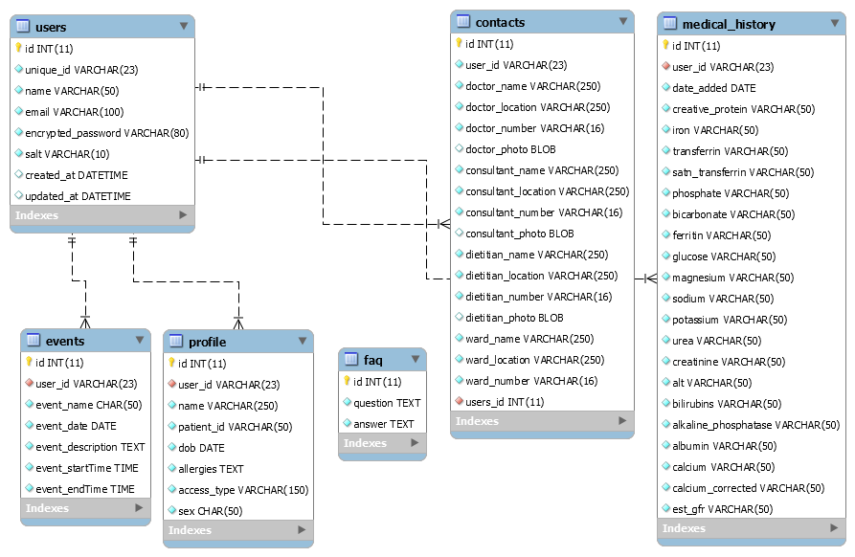

**FIGURE X: E-R diagtam for the created database**

**5.1.2 Implementation and testing**For server-side database management, it was decided to use HeidiSQL [REFERENCE X3], OpenSource tool, designed for browsing and editing data in MySQL databases. It offered simple user interface and all the esential functionality at the same time. The decision was made due to previous experience of working with this tool. Created database was named “renaldialysisdb” to suit project’s name. It consisted of six tables, each having its own purpose. All the tables had primary keys and foreign keys. For the primary key in each table, unique integer field “id” with auto-increment was created. The database had six tables: “users”, “profile”, “contacts”, “events”, “medical history” and “faq”. Apart from “faq”, all the tables were related to “users” table on “unique_id” field, using foreign key “user_id”. Using foreign keys allowed to cross-reference related data across table. Due to the fact that “faq” would contain data that will remain same for all the users, it was decided not to include foreign key in this table. Each of the created table had its own purpose:

* users – *storing user authorisation data: id of the user in a table, unique_id, username, email address, encrypted password and salt for its decryption.*
* profile – *storing user details: profile id, id of the user this profile belongs to, patient’s name, hospital id, date of birth, allergies, access type for dialysis and gender.*
* contacts – *storing essential contacts: contacts id, id of the users these contacts belong to, doctor’s name, phone number, location and photo, consultant’s name, phone number, location and photo, dietitian’s name, phone number, location and photo and ward’s name, phone number and location.*
* events – *storing calendar events assigned for the user: event id, id of the user this event belongs to, event name, date, description, start time and end time.*
* medical history – *storing patient’s medical history (in blood test results): id of the medical history, id of the user this history belongs to, date when results were added, c-reactive protein value, iron value, transferrin value, SATN transferring value, phosphate value, bicarbonate value, ferritin value, glucose value, magnesium value, sodium value, potassium value, urea value, ALT value, bilirubins value, alkaline phosphatase value, albumin value, calcium value, corrected calcium value and estimated GFR value.*
* faq – *storing frequently asked questions and answers: question id, question and answer.*

When creating fields, attention was paid to selection of appropriate data types. As the result, INT was selected for storing primary keys, VARCHAR for storing short texts or values, CHAR for calendar event names, TEXT for longer texts, such as calendar event descriptions or question and answers in “faq”, DATE for storing dates and TIME for storing times, DATETIME where combination of both was needed, BLOB for storing images or other large objects.

Manual testing was performed to test the database for successful store of data. Manual testing is the process of manually testing software for defects. It requires a tester act as an end user to use the most of all application’s functionlity to ensure correct behaviour. According to the procedure of manual testing, test plan[APPENDIX X] was created and the test was performed by querying (Code Snippet 1) the database after data addition to check for successful store.

**SELECT** `id`, `user_id`, `name`, `patient_id`, `dob`, **LEFT**(`allergies`, 256), `access_type`, `sex` **FROM** `renaldialysisdb`.`profile`;

***Code Snippet 1:*** *Making database queries to check for successful store*

**6 Phase 1**

**6.1.1 Design  
6.1.2 Implementation and testing**

**7 Phase 2  
7.1 Design  
7.1.**

**7.1.2 Implementation and testing**

**7.1.1**

**8 Phase 3**

References:

[1.1] https://www.renalreg.org/wp-content/uploads/2015/01/web_book_07-04-16.pdf

[1] http://www.nhs.uk/conditions/Kidney-disease-chronic/Pages/Introduction.aspx

[2] <http://www.healthcheck.nhs.uk/document.php?o=81>

[2.1] Saran R, Li Y, Robinson B, et al. US Renal Data System 2015 Annual Data Report: Epidemiology of Kidney Disease in the United States. Am J Kidney Dis, in press

[2.2] http://www.tkpa.org.uk/

[3] <https://www.nice.org.uk/guidance/cg182/chapter/1-recommendations>

[4] <http://patient.info/health/chronic-kidney-disease-leaflet>

[5] <http://www.nhs.uk/Conditions/Kidney-transplant/Pages/Introduction.aspx>

[6] <https://www.renalreg.org/wp-content/uploads/2014/09/Chapter_5.pdf>

[7] <http://www.niddk.nih.gov/health-information/health-topics/kidney-disease/hemodialysis/Pages/facts.aspx>

[8] <https://www.patientview.org/#/>

[9] https://www.kidney.org/apps

[10] NHS ethics committee

[11] http://www.tasc-research.org.uk/images/cmsimages/pdf/Caldicott%20Approval%20Procedure.pdf

[12] https://www.kidney.org

[13] http://labtestsonline.org.uk/

[14] <https://www.renalreg.org/>

[15] <http://www.srr.scot.nhs.uk/>

[16] <http://agilemanifesto.org/iso/en/>

[17] <http://agilemanifesto.org/principles.html>

[18] IEEE Std 100-1992

[19] <http://www.chambers.com.au/glossary/rationale.php>

[20] http://www.usability.gov/how-to-and-tools/methods/personas.html

[21] http://www.usability.gov/how-to-and-tools/methods/personas.html

[22] http://www.agilemodeling.com/artifacts/userStory.htm

[23] <http://www.usability.gov/how-to-and-tools/methods/use-cases.html>

[24] https://www.atlassian.com/agile/backlogs

[26] <http://www.tutorialspoint.com/dbms/dbms_data_schemas.htm>

[X1] <https://www.scrumalliance.org/community/articles/2008/september/what-is-definition-of-done-(dod)>

[X2] <https://www.apachefriends.org/index.html>

[X3] http://www.heidisql.com/